**Rep. Barry Loudermilk   
U.S. House of Representatives, GA-11**

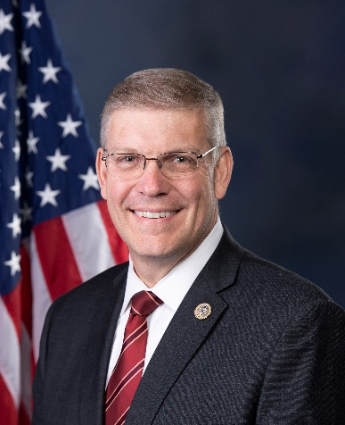Barry Loudermilk is a Constitutional Conservative who represents northwest Georgia’s 11th Congressional District.   
  
Prior to being elected to the U.S. House of Representatives in 2014, Congressman Loudermilk served in the Georgia General Assembly in both the State House and State Senate.

During his time in Congress, Rep. Loudermilk has served on the Committees of Science, Space and Technology, Homeland Security, the Joint Committee on the Library, Committee on House Administration, and Financial Services Committee. In his first year in Congress, he was appointed Chairman of the Oversight Subcommittee on Science, Space and Technology and served on the Homeland Security Committee’s Special Task Force for Countering Terrorism and Terrorist Travel.

In the 119th Congress, Congressman Loudermilk serves as a member of the Financial Services Committee, where he is the Vice Chair of the Subcommittee on Financial Institutions and is a member of the Subcommittee on Oversight and Investigations. The Subcommittee on Financial Institutions oversees banks, bank regulators, and lending, and the Subcommittee on Oversight and Investigations ensures that federal financial regulators are held accountable for their use of taxpayer funds. He also serves as a member of the Committee on House Administration and is a member of the Subcommittee on Elections.

Congressman Loudermilk is also a member of the conservative Republican Study Committee and is the Republican Co-Chair of the Bipartisan FinTech and Payments Caucus.

In the 118th Congress, House Speaker Kevin McCarthy tasked Congressman Loudermilk to lead the Committee on House Administration’s Subcommittee on Oversight investigation into the events at the Capitol on January 6, 2021, the security failures of the U.S. Capitol Police, and the flawed investigation of House Select Committee on January 6.

His father served as an Army medic in World War II and saw action during the D-Day invasion, Battle of the Bulge, and the Occupation of Germany. In 2019, Rep. Loudermilk was selected as one of the official delegates to represent the United States at the 75th anniversary of the D-Day invasion in Normandy.

He is native of Georgia and veteran of the U.S. Air Force. Rep. Loudermilk is a student of the Constitution and the Christian heritage of America. Barry resides in northwest Georgia with his wife, Desiree. They have three grown children, and seven grandchildren.